

|  |
| --- |
| **Plan of Approach** |
| Designing an Autonomous Robot Player for Connect-4 |
| *Name of client:*  ALTEN  *Name of supervisor:* Michael van der Velden  *Publication date: 6-Mar-23* |
|  |





|  |  |  |  |
| --- | --- | --- | --- |
| Version History | | | |
| Version | ***Date*** | ***State*** | ***Comment*** |
| 1 | 10-02-2023 | Draft | First draft set-up |
| 2 | 13-02-2023 | Draft | Put main bodies of text |
| 3 | 16-02-2023 | Finalizing draft | Correction from the feedback from the technical supervisor |
| 4 | 03-03-2023 | Final version | Correction after the supervisors meeting |
| 5 | 06-03-2023 | Final version | Correction from feedback |

|  |  |
| --- | --- |
| Acronyms and Abbreviations | |
| Term | **Explanation** |
| PoA | Plan of approach |
| BSP | Board support package |
| OS | Operating system |

|  |  |  |  |  |
| --- | --- | --- | --- | --- |
| Referenced documents | | | | |
| ID | **Reference** | **Title** | **Date** | **Author** |
|  |  |  |  |  |
|  |  |  |  |  |

Index

1. Background information: 2

2. Project results: 3

2.1 Goals of the project: 3

2.2 Problem definition: 3

2.3 Description of the project result: 3

2.4 Design model 4

3. Project activities: 4

4. Project limits: 5

5. Intermediate milestones: 5

6. Planning: 6

7. Risks: 6

# 1. Background information:

My graduation internship for Fontys Hogeschool will be conducted at the company ALTEN, with my task being to realize an embedded software architecture on an STM32H7 processor, for their 4-in-a-row robot, which was previously designed by another graduation project.

ALTEN is an international Technology and IT consultancy and Engineering company. Originally ALTEN was created in 1988 in France and currently they span over thirty countries with over 54100 employees, having established themselves in all the major sectors: Aeronautics & Space, Defence & Naval, Security, Automotive, Rail, Energy, Life Sciences, Finance, Retail, Telecommunications and Services.

Within the Netherlands, their expertise falls within the following categories: ALTEN IT, Technical Software and Mechatronics. The 4-in-a-row project falls within the Mechatronics department. Where my technical supervisor, Michael van der Velden, is also working as a consultant for ASML. With over 20 years of experience in the electrical engineering industry and weekly progress meetings, he has enough technical knowledge to guide me successfully through the project. Additionally, I have an appointed business manager, Gijs Haans, who is responsible for our personal development within the company and progress as engineers.

ALTEN has in-house projects, which are often used to develop new skills for consultants or the ones of interns. The 4-in-a-row (Connect4, Four Up) robot was developed for demos at trade fairs and open days at universities. The robot game is meant to demonstrate the knowledge of the consultants of ALTEN, and it is therefore developed with industrial components.

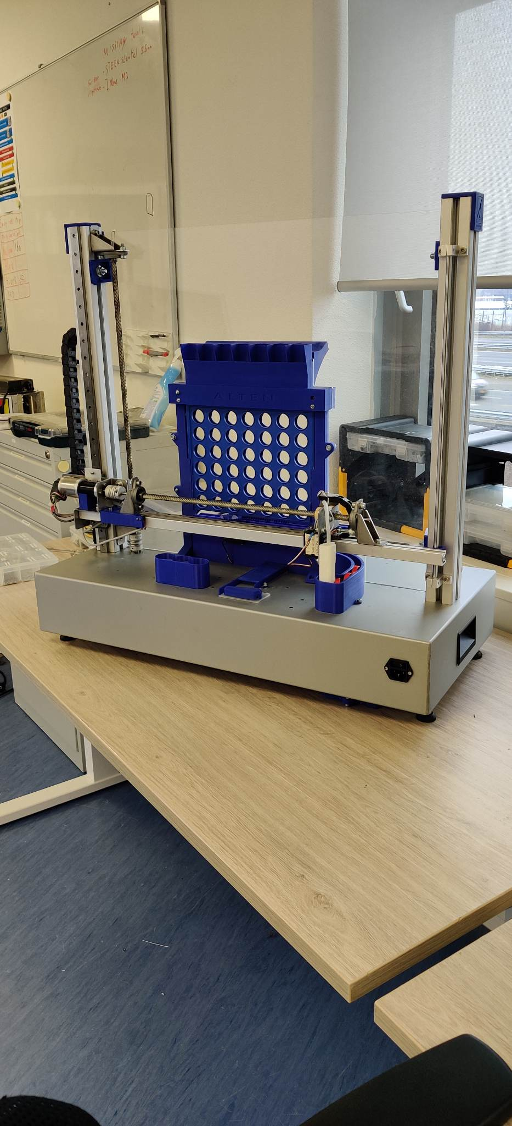The game is simple, there is a seven-by-six rack board, with slots at each spot for two coloured tokens. A red one and a yellow one. The first player to Connect 4 tokens in any direction wins. In our case, one player is a human, the other one is a robot. It is a completely autonomous process. After a token has been placed in the idle robot, the machine can calculate its next move based on a difficulty setting. To be able to execute everything, the 4-in-a-row robot is equipped with ‘X’ and ‘Z’ plane motors, a rotating vacuum gripper, and a routine to clear the board and reset the tokens.

Figure : Connect4 Robot

# 2. Project results:

## 2.1 Goals of the project:

Implement the previously designed software architecture for the new STM32H755ZIT6U controller. Previously this system and its last iteration were running on a single Cortex-M4 core. Which was not powerful enough to provide resources for the software and hardware expansions ALTEN wanted to introduce to it. Therefore, they decided to upgrade the system with a dual-core processor. With this new requirement, a new architecture was designed and its feasibility was proven with a demo code.

My task will involve designing the modules to make the system reliable and functional to the best of its capacity. That will involve writing code for the needed modules, improving and adapting flowcharts/logic, and redesigning modules that do not function as expected from the software architecture. Further steps will include the further optimization of the BSP and testing on the robot itself. Moreover, research on ethernet communication with the robot will also be investigated, as a secondary goal.

The project will not involve integrating the game-logic part (the module where the next decision for the robot is made), on the Cortex-M7 core, but it will keep its function as it is currently.

## 2.2 Problem definition:

As mentioned before, the system has had an upgrade in hardware and because of that a new architecture was designed. My task is to implement the new dual-core architecture by validating/testing the design and by implementing the necessary software modules to make the 4-in-a-row robot perform more reliably. Secondary to that goal is the research of ethernet communication with the system. That will ensure that future upgrades of the system have a starting point to go off of.

Within the software architecture, I have complete freedom of design and choice in implementing the functions and how they are programmed. Alongside the ability to re-evaluate the designed modules and if needed redesign them after agreement with the client.

## 2.3 Description of the project result:

1. Designed software modules from the architecture design.
2. Tested modules on the Connect4 robot.
3. Research on ethernet communication for the system.

## 2.4 Design model

The V-Model is a useful tool to manage and deliver projects. By using this model, the student can ensure that their project is completed systematically and efficiently, and that the requirements set out at the beginning of the project are met.

Figure : The V-model

# 3. Project activities:

1. Research key concepts about STM32
   1. Memory, Timers, Interrupts, Communication protocols, etc.
2. Redesigning flowcharts for software modules
3. To study and get familiar with the environment of the STM32 controller
4. Programming modules from the architecture
5. Implementing modules from the architecture on the hardware

The programming done on this project will be in C/++.

# 4. Project boundaries:

The project is concerned with the re-evaluation (and if needed redesign) and

Figure : Cortex-M7 block diagram

Figure : Cortex-M4 block diagram

implementation of the previously designed software architecture. The dual-core communication is worked out, but the rest of the modules(blocks) have to be implemented. More modules are building up than the ones seen in the diagrams below.

Table : Scope of project

|  |  |
| --- | --- |
| **Project boundaries** | **Within Scope ?** |
| Implement software modules | Yes |
| Redesign software modules | Yes |
| Research ethernet communication | Yes |
| Implementing ethernet communication | No |
| Redesign hardware/mechanics | No |
| Changes to the gameplay | No |

# 5. Intermediate milestones:

1. System Requirements Document / System Design Document
2. Implementation of modules
3. Test Plan

# 6. Planning:

Figure : Planning of the project

# 7. Risks:

|  |  |  |  |
| --- | --- | --- | --- |
| Risk description | Likeli­hood | Impact | Risk |
| Context: Hardware failure  Event: Component malfunction | 2 | 3 |  |
| Context: Software bugs  Event: Software modules not working as expected | 2 | 4 |  |
| Context: Integration issues  Event: Unresponsive while testing new software modules | 4 | 2 |  |
| Context: Time constrain  Event: Failure to complete tasks due to poor time management and/or unexpected events | 2 | 2 |  |
| Context: Unclear scope of project  Event: Unclear user requirements | 1 | 3 |  |
| Context: Wrong logic in state machines  Event: Wrong behaviour of the system | 1 | 1 |  |

Table 2: Risk list

|  |  |  |  |  |
| --- | --- | --- | --- | --- |
| **Likelihood** | **Consequences of impact** | | | |
|  | **1** | **2** | **3** | **4** |
| **4** | **4** | **8** | **12** | **16** |
| **3** | **3** | **6** | **9** | **12** |
| **2** | **2** | **4** | **6** | **8** |
| **1** | **1** | **2** | **3** | **4** |

Table 3: Qualitative risk analysis matrix